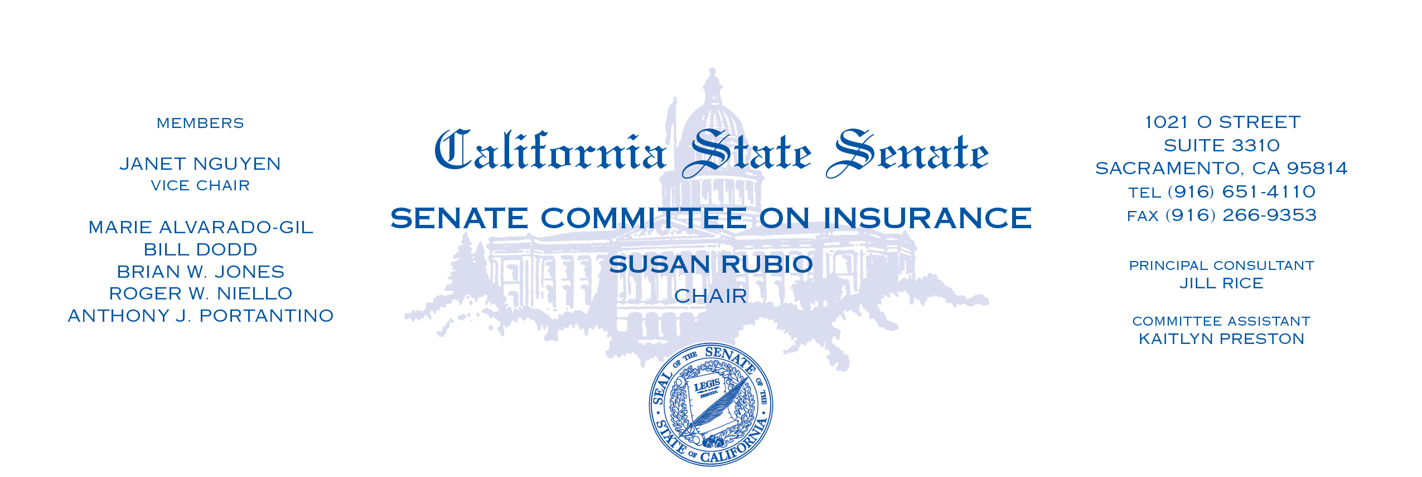

**AGENDA**

**Oversight Hearing**

**Wednesday, January 24, 2024**

**1021 O St. Room 2100**

**1:30pm-2:30pm**

**CALIFORNIA DEPARTMENT OF INSURANCE:**

**SUSTAINABLE INSURANCE STRATEGY**

**A Progress Report on Insurance Market Stabilization**

**I. Introduction and Opening Remarks**

***Senator Susan Rubio, Chair, Senate Insurance Committee***

*Other Members*

**II. Sustainable Insurance Strategy**

***Honorable Ricardo Lara****, Commissioner, California Department of Insurance*

**III. Public Comment and Closing Remarks**