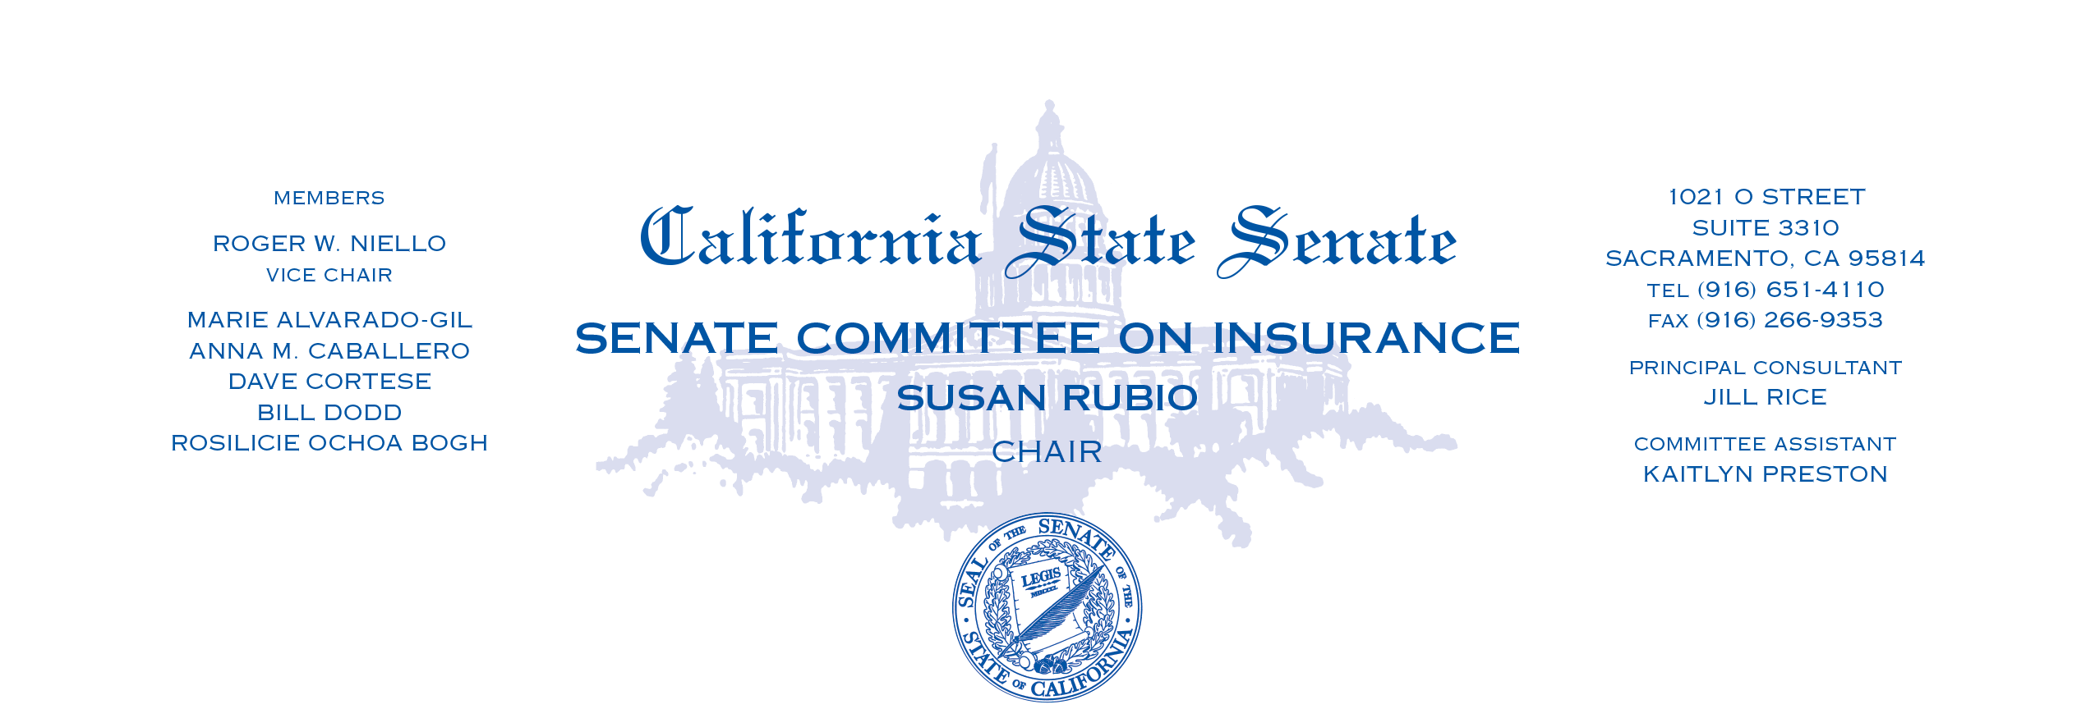
AGENDA
Wednesday, June 26, 2024
12:30 p.m. – State Capitol, Room 113

MEASURES HEARD IN FILE ORDER

1. | AB 2416 | Connolly | Residential Property Insurance: wildfire risk.
2. | AB 2996 | Alvarez | California FAIR Plan Association.

