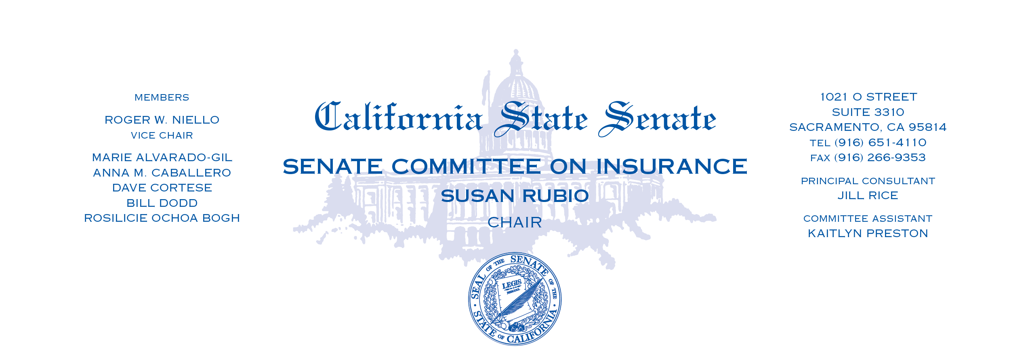
AGENDA
Wednesday, June 12, 2024
1:30 p.m. -- 1021 O Street, Room 2100

MEASURE ON PROPOSED CONSENT

1. | AB 1844 | Calderon | California FAIR Plan Association governing committee.  (Committee Pull)
MEASURES HEARD IN FILE ORDER

1. | AB 1505 | Rodriguez | California Earthquake Authority: closed meetings.
2. | AB 2416 | Connolly | Residential property insurance: wildfire risk.  (Author Pull)
2. | AB 2743 | Pacheco | Insurance: personal vehicle sharing.

