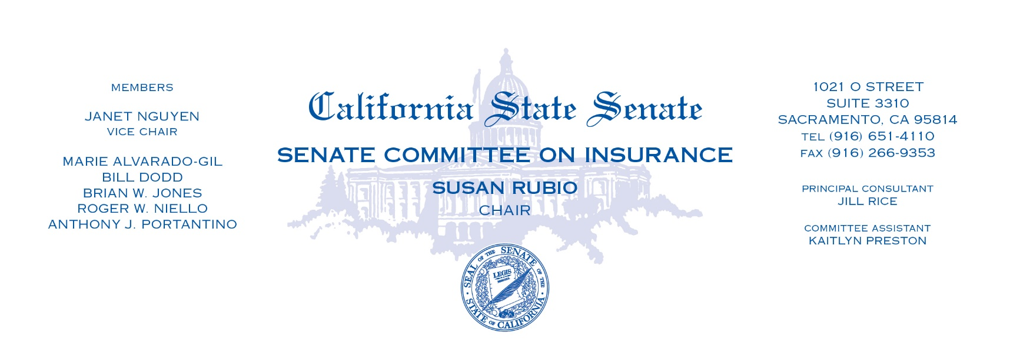
Oversight Hearing
Wednesday, January 24, 2024
1021 O St. Room 2100
1:30pm-2:30pm
CALIFORNIA DEPARTMENT OF INSURANCE:
SUSTAINABLE INSURANCE STRATEGY
A Progress Report on Insurance Market Stabilization

Summary
In September 2023, Governor Newsom issued executive order N-139 which urged Insurance Commissioner Lara to take immediate action to address the current homeowners insurance crisis, protect and expand coverage options for consumers, and keep plans affordable. A copy of the executive order can be found here.
Background
Citing the role of climate change and its threat to communities via more extreme wildfires, floods, and droughts, Governor Gavin Newsom highlighted the crisis in the state insurance markets. In September 2023, he urged Insurance Commissioner Ricardo Lara to take action to stabilize and improve California’s property insurance marketplace with the following goals:
First, expand coverage choices for consumers, particularly in underserved areas of the state while maintaining the long-term availability of homeowners and commercial property insurance coverage. Second, improve the efficiency, speed, and transparency of the rate approval process. This included tailoring the rate approval process to account for all factors necessary to promote a robust, competitive insurance marketplace. Third, maintain the solvency of the FAIR Plan to protect its policyholders and promote long-term resiliency in the face of climate change, including by identifying mechanisms to reduce its share of the overall market in underserved areas and move its customers into the admitted insurance market. Finally, the executive order directed the Department of Finance to consult with the California Department of Insurance to support the rulemaking process and help accelerate implementation of potential regulations.

California’s Sustainable Insurance Strategy

In response to a convergence of factors, including the climate crisis, rising inflation, and unprecedented challenges in California's insurance market, Commissioner Lara developed the California Sustainable Insurance Strategy. This strategy is a comprehensive initiative aimed at modernizing the state's insurance market to ensure accessible insurance for all Californians, create a resilient insurance marketplace, and protect consumers and communities from the adverse impacts of climate change. It addresses the challenges posed by rising global inflation, increased insurance costs for rebuilding, and the growing risk of natural disasters. The California Sustainable Insurance Strategy is crucial because it addresses the pressing issues faced by both the insurance market and consumers in California. It responds to the changing landscape of insurance by enhancing market stability, improving consumer access to coverage, and safeguarding against the escalating financial burden of climate change-intensified catastrophes and global inflation.

Commissioner Lara's strategy sets forth three primary goals, with a clear commitment to consumer protection and insurance market sustainability:
- Accessible Insurance for Californians: This goal emphasizes the importance of making insurance available and affordable, especially in high-risk areas affected by climate change.
- Create a Resilient Insurance Market: The strategy aims to fortify the insurance market's resilience in the face of climate change and economic fluctuations, ensuring it can effectively weather these challenges.
- Protect Communities from Climate Change: Implementing measures to shield communities from the devastating impacts of climate change, such as wildfires and other natural disasters, is a paramount objective.

Conclusion
The committee’s purpose in this hearing is to provide the Insurance Commissioner Lara with feedback on his progress toward his stated goals in his California Sustainable Insurance Strategy. Specifically, the implementation of his regulations and timelines to date. Most importantly, the Senate will be focused on how this strategy is benefitting and protecting consumers.

